Attachment A
VWL No. 16-05 Change 1 Incumbent Worker Training

Desk Reference Checklist for Incumbent Worker Training Data Entry Process

Note: It is important to mention that this document was created based on the most current feedback received from the Department of Labor Employment and Training Administration (DOL-ETA). Incumbent Worker Training is a new topic under WIOA (Workforce Innovation and Opportunity Act) and additional clarification is forthcoming, however this document was produced with the most recent information and guidance available.

We are required to meet certain minimum reporting requirements that are related to the current PIRL (Participant Individual Record Layout) reporting, therefore this document was created with these data collection and reporting requirements in mind.

We will continue to request additional guidance and clarification; however we are providing this solution at this point in time in an effort to move this Incumbent Worker Training initiative forward.

We are also pursuing system enhancements that will help streamline the Incumbent Worker intake and reporting process. To finalize any system enhancement, we will need specific and detailed reporting guidance in the form of a TEGL or other written guidance from DOL-ETA. We will continue to evaluate system enhancements and other alternatives; however until DOL-ETA can provide more specific detail on specific program reporting requirements, it will remain difficult to reprogram the system to collect less data and in a less structured format for Incumbent Worker Individuals, while remaining compliant within the currently required data collection and reporting requirements.

This is currently the most efficient and effective means by which we can record service to individuals receiving Incumbent Worker Training and also meet the current reporting requirements set forth by DOL-ETA. We will continue to review methods through which we may be able to make this process more efficient.

Keying Individuals receiving Incumbent Worker Training activities funded through WIOA into the Virginia Workforce Connection
Individuals that receive Incumbent Worker training activities funded through WIOA Title 1 must be recorded within the Virginia Workforce Connection (VaWC) so that these Individuals may be properly reported.

Virginia Workforce Connection (VaWC)
- Individuals must be registered in the Virginia Workforce Connection (VaWC). In situations where the employer is unable to provide certain data elements, the individual can be directed to complete their own system registration. This process could alleviate concerns such as in cases where the employer is reluctant to provide SSN or perhaps is unaware of other required demographic information.
- Employers must provide a list of all Individuals receiving Incumbent worker training. A list of all the required data items can be found in Attachment B. If an Individual is already registered, the Employer can provide the VaWC system user ID instead of the Individual’s SSN (such as in the situation described in item 1).

- Regardless of approach used to register the Individual within the system, staff must complete a WIOA Application for any individual that receives Incumbent Worker training through WIOA Title I funds. In the absence of other reporting guidance, TEGL 3-15 indicates that all Incumbent Workers should be reported in the WIASRD (Workforce Investment Act Standardized Record Data), which was subsequently replaced by the PIRL (Participant Individual Record Layout); therefore sufficient information must be collected in order to complete the WIOA application and produce the required reports.

Note: Additional guidance related to the PIRL (Participant Individual Record Layout) and other reporting requirements may still be forthcoming. The VaWC and the WIOA Application will ultimately be used to create and comply with DOL published reporting requirements.

Though some of the WIOA Application questions are not specific to Individuals receiving only Incumbent Worker Training, it is still required that information be collected. The Final Rule indicates that individuals receiving Only Incumbent Worker training are not subject to the same eligibility criteria as those that participate in Adult or Dislocated Worker activities. While this distinction is noted, it is still required that sufficient information be collected in order to produce a PIRL Reporting file; even though
these elements would not directly impact an individual’s eligibility for Incumbent Worker Training.

- Staff must still verify DOB and Authorization to work (Citizenship) for all Individuals; and Selective Service Registration where appropriate. See Attachment B for Employer certification.

- Staff will need to click on the Link to Create the WIOA program within the programs tab to work with the WIOA Application.
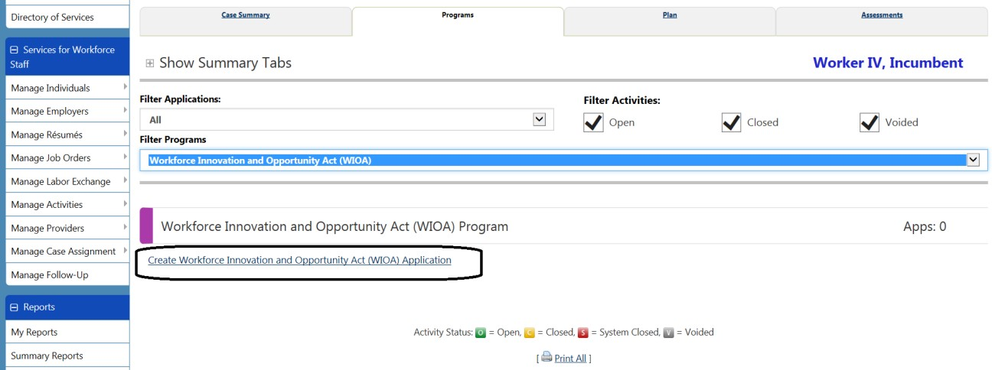
6 - Once in the WIOA Application is open, the staff will navigate through the application Wizard. On the Start tab, staff will use the “Incumbent Worker Eligibility” check box to select and utilize the Incumbent Worker Application.

(Note – Staff will also indicate the use of “Incumbent Worker Eligibility” at the end of this application. The Incumbent Worker Customer Program Group should be used for all Individuals that receive only Incumbent Worker training and this process will be described later in this document.)

As staff begin the process of creating the application, they may use the date of Incumbent Worker Training Contract with employer or other more appropriate date as the WIOA Application and Eligibility dates. Any unique processes used or oddities encountered during the application process should be recorded in a case note within the system.

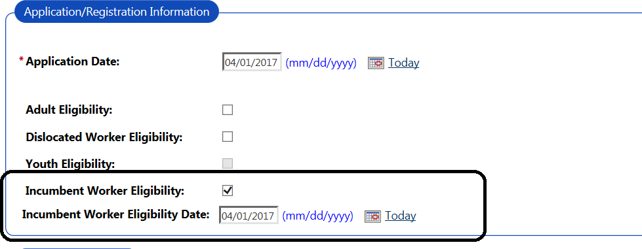

Staff will scroll down the page and update any required field; including region and responsible office, then click the “Next” button at the bottom of the page to continue through the WIOA application.

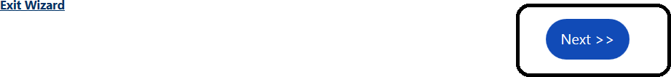

The Incumbent Worker Eligibility application offers less data collection and fewer verification requirements than found in the more traditional WIOA application. There are a number of data fields and verification options that appear within the application; however staff will only be required to complete the verification options found on the “Demographics” tab.

7- On the Demographics Tab, staff will need to add/update and verify the Individual’s Date of Birth, Registration for the Selective Service and the Authorization to Work in the U.S. elements. These should be the only elements within the system that staff are required to select verification before advancing to the next scree/tab. See Attachment B for Verification requirements.

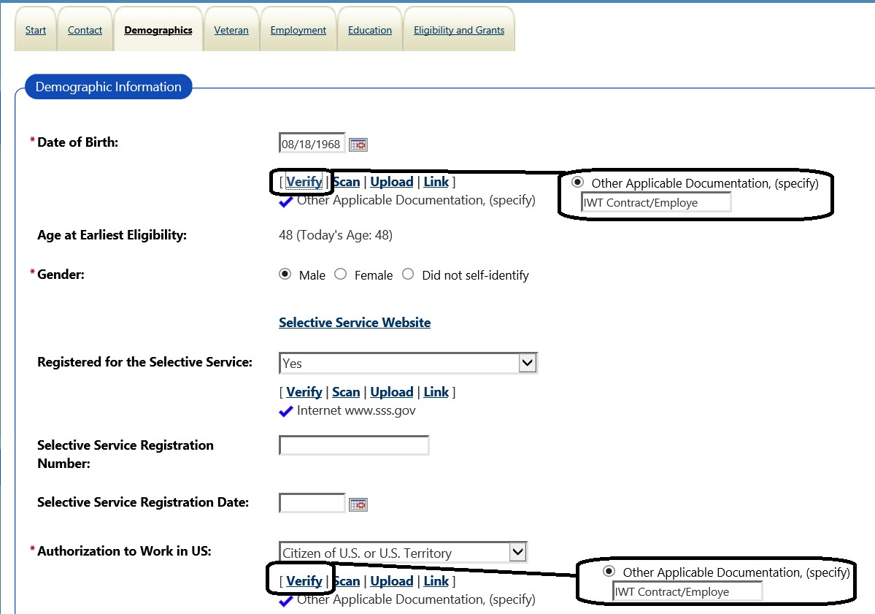
If no other verification is available and/or the employer has provided sufficient verification information, staff may verify these required items using the category “Other Applicable Documentation” and add a comment (such as “IWT Contract/Employer” or “IWT Employer Certification”) to the text box. This approach may be used, where appropriate, for other verification options within the Incumbent Worker Individual’s WIOA application.
- – Staff will advance through the application and navigate to the “Employment” tab. Staff will need only to indicate that the Individual is currently “Employed” and the “Unemployment Eligibility Status” maybe set to “Unknown” or “Neither a Claimant or Exhaustee” (by the nature of being an Incumbent Worker) on the Employment tab. The system should not require any verification for elements on this page. Staff may scroll down the page an advance to the subsequent page using he next button.

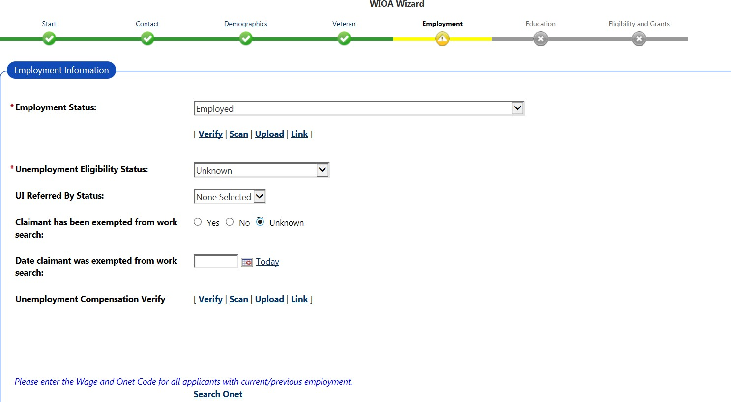

- - Staff will continue through application and navigate to the Eligibility and Grants tab. Staff should see the term “Undetermined” attached to the tradition WIOA Title I Adult, Dislocated Worker and Youth Programs if they have followed the steps so far and selected only the Incumbent Worker Eligibility.

In the WIOA Grants Eligibility section, the staff will see the following statement under the Incumbent Worker Eligibility:
“Applicant meets the basic requirements for Incumbent Worker eligibility, but staff must manually set this to “Yes” and add a grant, when appropriate.”
Staff will need to select “Yes” for the “Incumbent Worker Eligibility”. All Activities/Services attached to records that are to be reported only as Incumbent Worker Individuals must be attached to this customer program group.
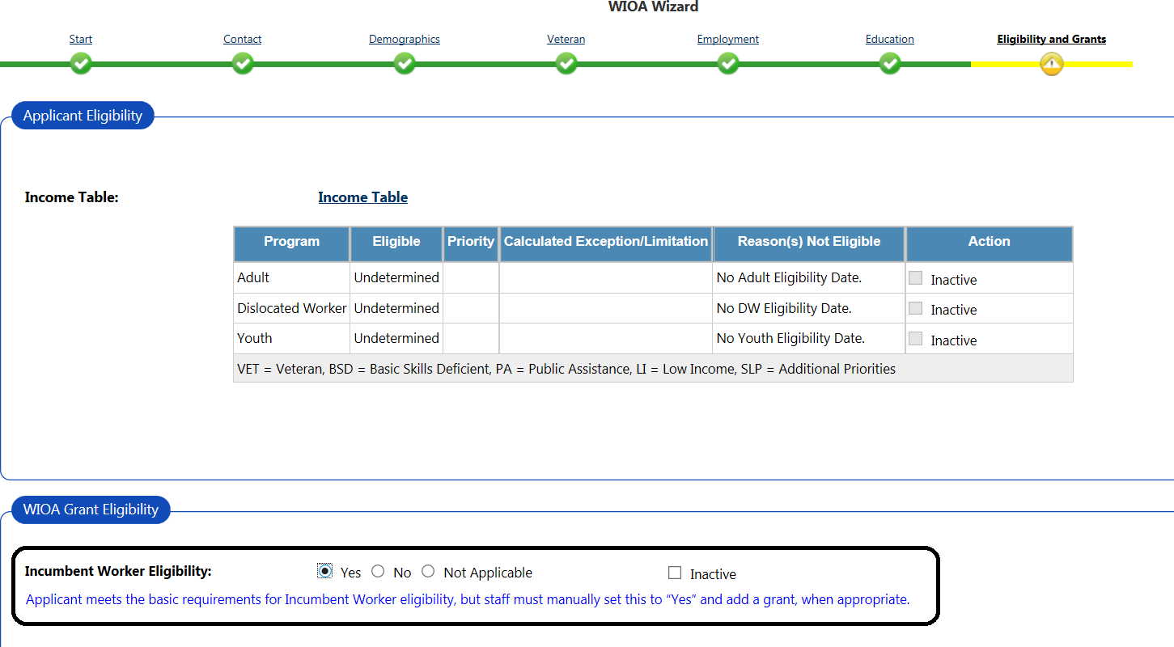
Continue down the page to the Grants section and click on the “View Available Grants” link.

- Staff will access Grants section and will need to select the appropriate funding to be applied to the Incumbent Worker activities.
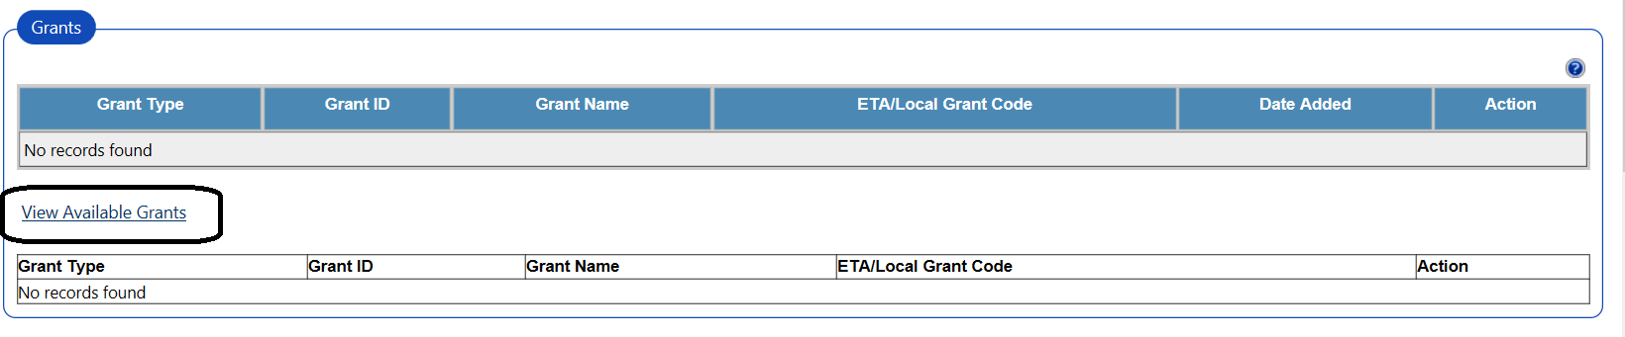

After clicking the “View Available Grants” link, staff will be given the opportunity to “Add” the appropriate “Grant Type”/ funding source to be applied to this individual.
Note: If this step is skipped and the specific Grant is not attached to the application, the appropriate funding selection will not be available when the Incumbent Worker activities are added.

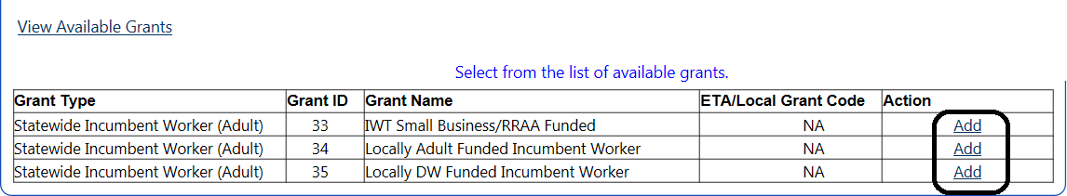
These three Grant Types have been added to the system:

IWT Small Business/RRAA Funded – this option should be selected for any Incumbent Worker activities that are part of the “IWT Small Business” Grant and provided through the use of Statewide Rapid Response Additional Assistance funds.

Locally Adult Funded Incumbent Worker - this option should be selected for any Incumbent Worker activities that are attached to Local WIOA Adult funds.
Locally DW Funded Incumbent Worker - this option should be selected for any Incumbent Worker activities that are attached to Local WIOA Dislocated Worker funds.
After clicking “Add” link and selecting the appropriate Grant type, the section should appear as follows.
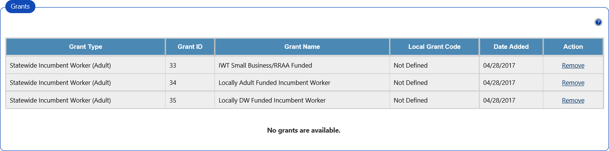
Note: The example above was used specifically to demonstrate all the Incumbent Worker funding sources currently available. It is not meant to represent what the record must look like. Staff do not need to select or make all sources available to the application; they need only select the specific source for the Individual.

With the appropriate funding source attached, staff may proceed to the bottom of the page to complete the application process. Staff may use one of the buttons at the bottom of the page to continue.
The “Next” button will save the application data and navigate the staff directly to the first service assignment. This is a step to speed staff through the process and was designed to assume that the day the application was completed within the system is also the start of the first service. Staff should use
the “Finish” button if the first service or indicator should have any date other than the day it is keyed.

The “Finish” will save the application, complete the process and return staff to the Individual’s Programs tab. This option offers staff more flexibility for saving the application and offer more alternatives for setting the start of the first activity.
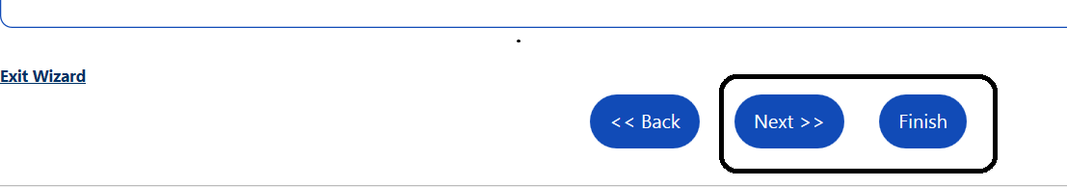
- After clicking “Finish” button; staff will be returned to the Programs Tab.

Staff may click on the “Create Participation” link to access the first service assignment.

The Program section now has a more compressed view. Staff may need to click in the gray Program Application Area to expand the program view.
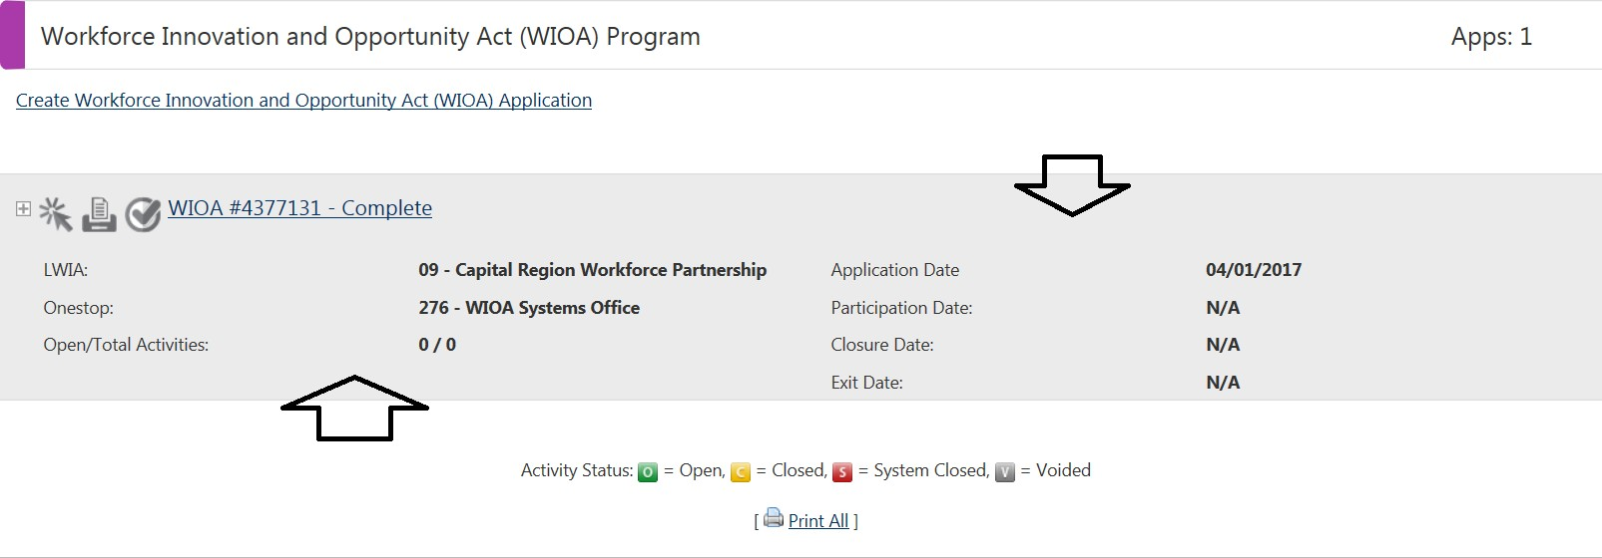

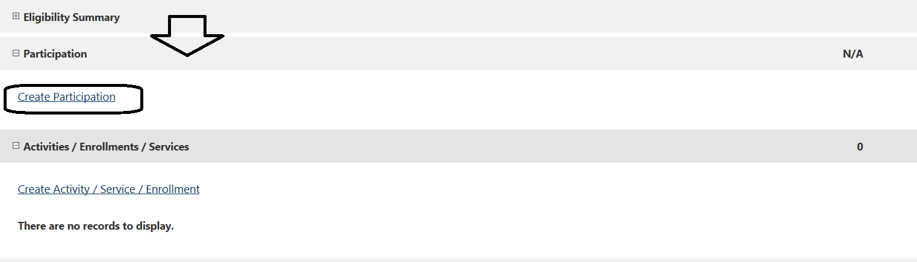
Once the view is expanded, the staff should be able to access the “Participation” section to access the “Create Participation” link to add the first Incumbent Worker activity.

Within the Program Participation screen, staff will be able to set the start of the first service and confirm if any other status may have changed since the application was completed. Staff should only need to set the start of the first activity on this page. The system should not require verification selections in this section for Incumbent Workers. After setting the Participation date, staff may scroll down and click the “Next” button to continue.
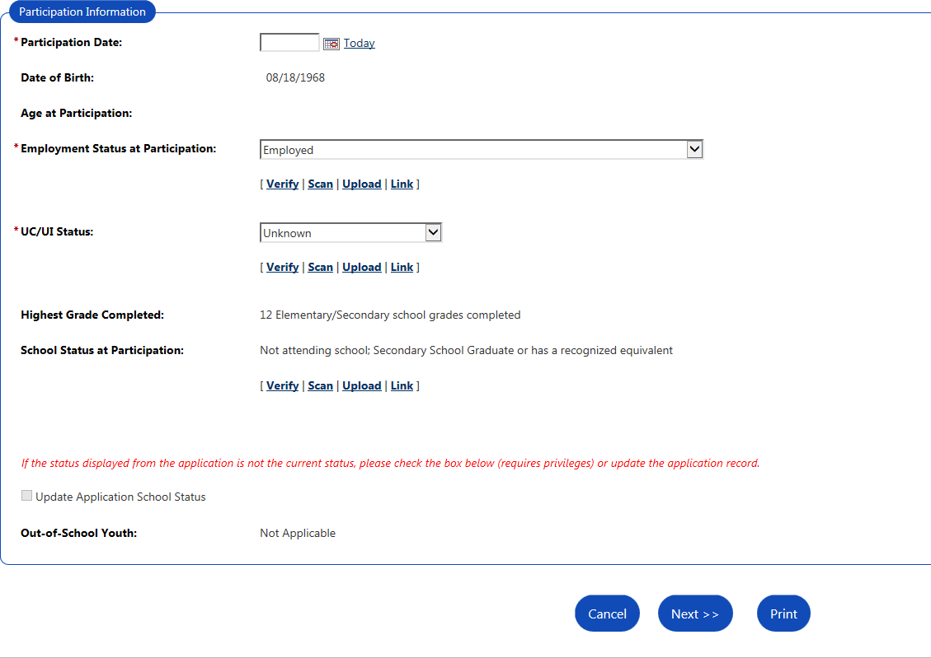

- - Staff will proceed through the service assignment and will need to add the appropriate Customer Program Group (Funding source) for the given activity. The Statewide Incumbent Worker Eligibility should be the only Customer Program Group that is available. Scroll down the page and select the specific Grant to be associated with this Incumbnet Worker. Staff will also need to select the Incumbent Worker Individual Identifier activity.
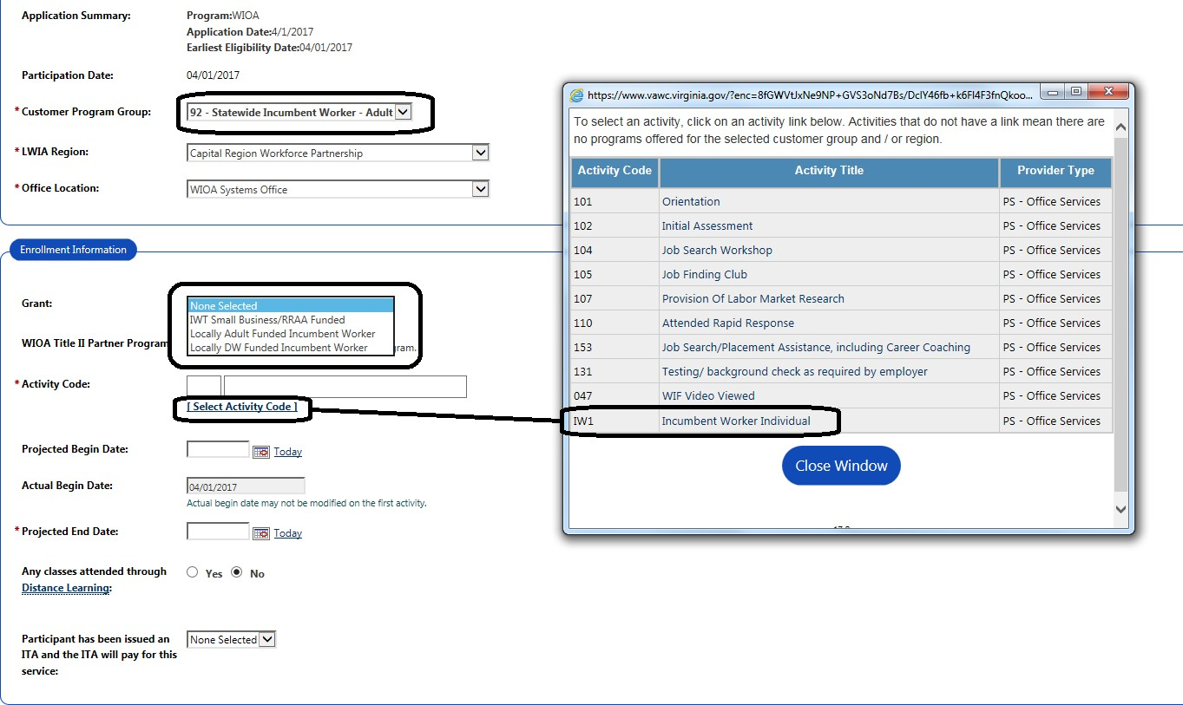

Staff will click on the “Select Activity Code” link and select the appropriate Incumbent Worker Individual activity.
In an effort to more specifically identify individuals that are in receipt Incumbent Worker Training; several new activity codes have been added to the system. The first activity added for any individual served only for the purpose of Incumbent Worker training should be the “IW1 – Incumbent Worker Individual” identifier (as shown in the picture above).

The activities that have been added to specific identify and track Incumbent Workers include:

IW1 - Incumbent Worker Individual – this would be the first service added to any Individual’s record that is attached to an employer that will be providing Incumbent Worker Training. This code is design to
identify or flag this person specifically as an “individual” and help differentiate this individual from participants in future reporting. Once the activity is in place, it will make available more specific Incumbent Worker Training activities.
IW3 - Incumbent Worker Training – With Credential – this activity would be added to the record of an individual engaged in Incumbent Worker Training and it is known that the ultimate outcome of this training would result in an Industry Recognized Credential, Certification or other reportable credential that will benefit the individual and this credential could be recorded within the system.

IW5 - Incumbent Worker Training – Without Credential - this activity would be added to an individual engaged in Incumbent Worker Training that will result in a gain of Industry recognized skills and help the individual retain their employment, however it is known from the beginning of training that this activity will not result in a Credential or Certification.

The purpose of these new codes will be to make it easier for staff to report on individuals receiving Incumbent Worker training and also more appropriately record and report the type of training these Individual are engaged in.

- Once the “IW1 - Incumbent Worker Individual” activity is in place; the record will appear as picture below.
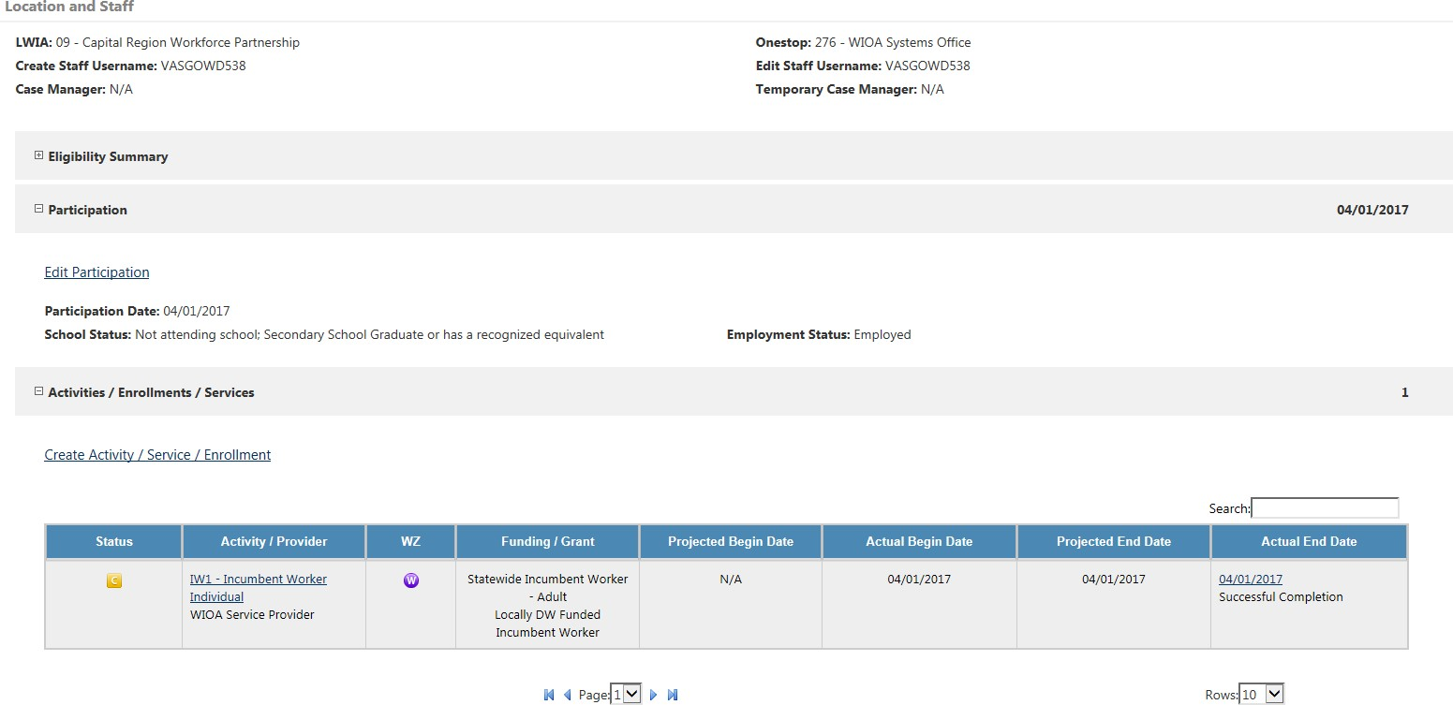
In this example; the Incumbent Worker activity is attached to Local Dislocated Worker Funds

- Once the Incumbent Worker Individual Identifier is in place, staff may click on the “Create Activity” link to add the appropriate Incumbent Worker Training activity to be associated to this individual.

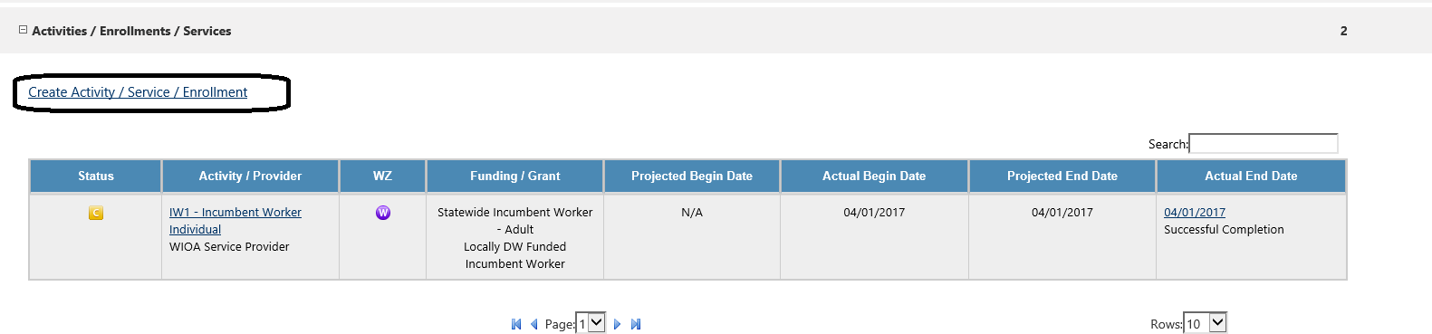
As staff enter the activity assignment, they will again want to be sure the Statewide Incumbent Worker Customer Group amd appropriate Grant is attached to the activity.

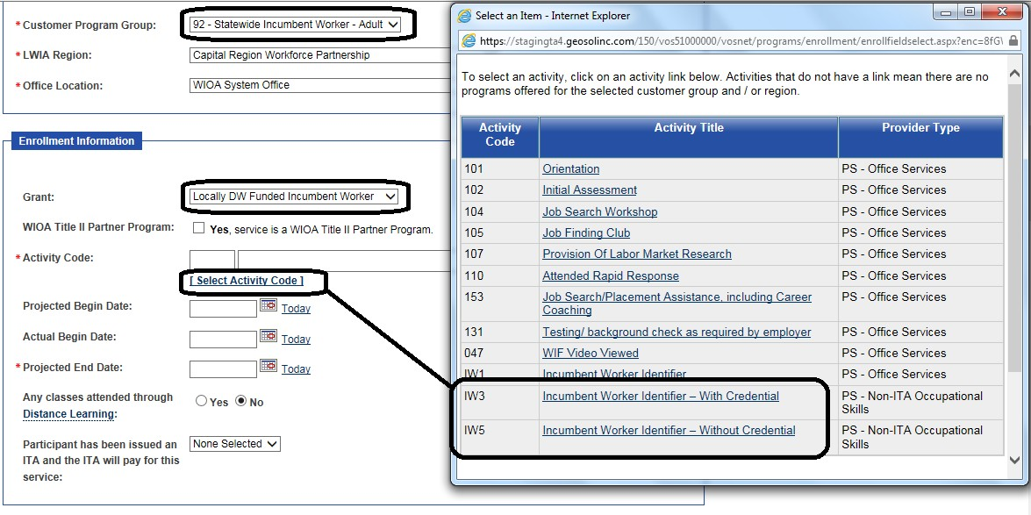

After making all the appriate selections, Scroll down and click next to advance to the Service Provider tab.
In an effort to streamline this process, a single provider has been made available to these Incumbent Worker Training activities and the service type will appear as “WIOA Incumbent Worker Training” as displayed below.
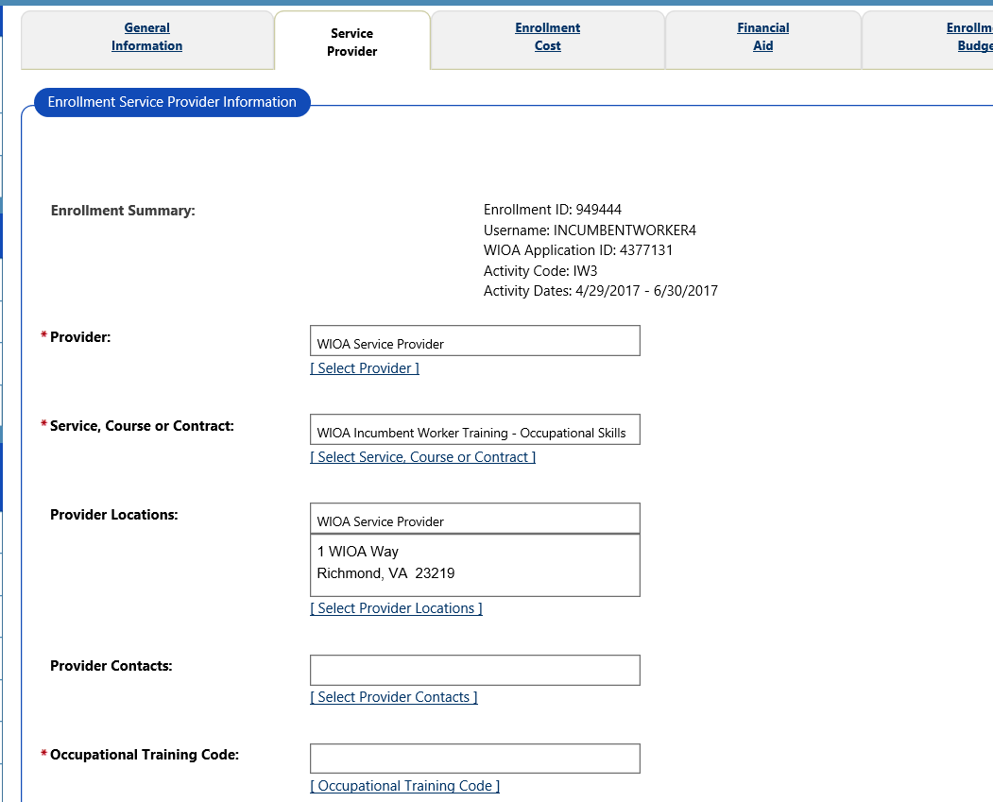
Note: Some LWDA may elect to add the specific provider of the Incumbent Worker training to the system through the same mechanism used for the more traditional Eligible Training Provider process. This option is not required and the provider would not need to go through the eligibility process traditionally associated with WIOA Eligible Training Providers, however, the appropriate staff would have to key the information within the provider section of the system. If this option is exercised, staff would have multiple providers to choose from and they would need to use the “Select Provider” link and attach the appropriate provider to be attached to this IWT activity.

If you still need to search and select the appropriate Occupational Traiing code for the individual then use the “Next” button to Proceed to last tab and use the “Finish” button to complete the process of adding the IWT training activity to the system.

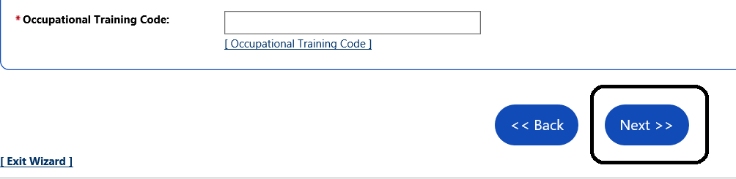
- - Once the appropriate Incumbent Worker Individual Identifier and Training activity is in place, the record should appear as pictured below.

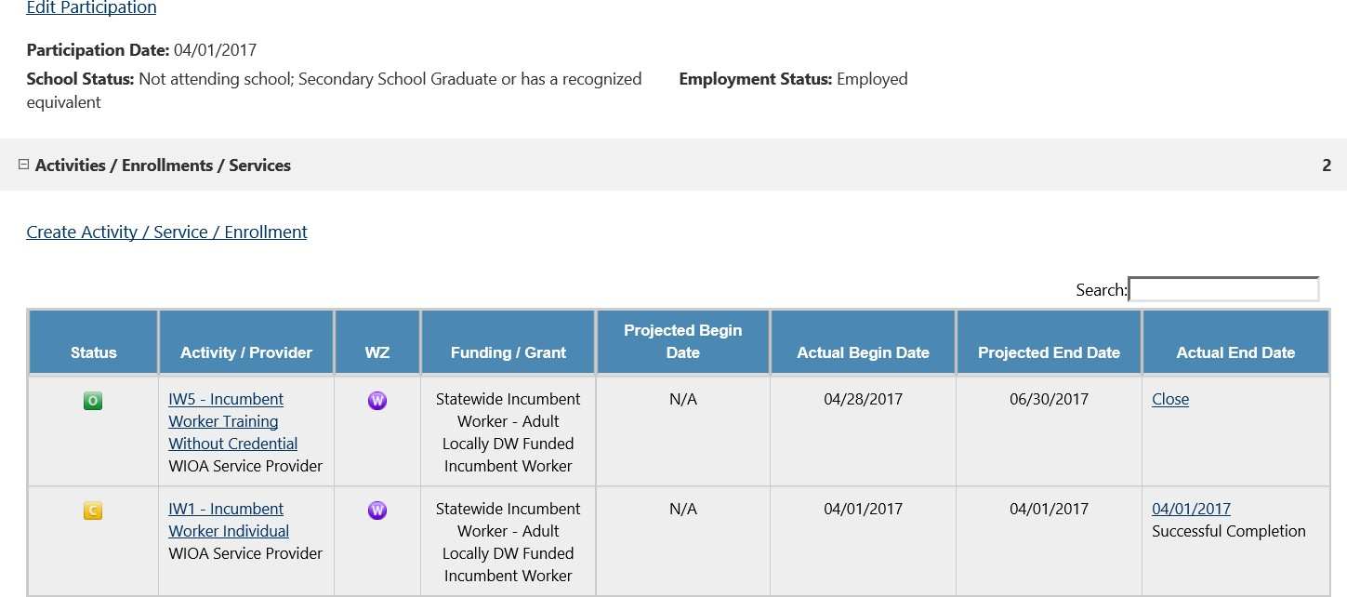
A Record that appears as the above pictured example will only be reported as an Incumbent Worker Individual.

At this point, no other activities need to be added to the record of an Individual that is receiving only Incumbent Worker Training. When training is complete, staff would need only to close the service codes with the appropriate end date, status and outcome.

Staff may use these activity codes to produce reports from the system related to Incumbent Workers served. Additional guidance on the use of the existing reporting function may be provided in a separate document.

Important Note: These Incumbent Worker Services were numbered with an “IW” and added to the system specifically for the Individuals that are going through Incumbent Worker Training. Those records that have only the “IW” services added will be captured and reported as Individuals only. Any record that has at least one of the other more traditionally numbered WIOA service codes will be considered to be Co-enrolled and would meet the requirement to be reported as a WIOA Participant.

If the record has any activities associated with any other Customer Program Group; that record would be subject to the full eligibility, reporting, performance and data validation requirements for said program.

This document may be modified and updated as additional reporting guidance and system enhancements become available.

